- Ladre is a small scaled family business found in 2000s which selling computers’ hardware and software. Recently the shop owner plans to improve the business by selling the products online. He has contacted your company as a suitable software house to handle this project.
Discuss the 3 main activities that your team would perform for the architectural design of the above project.
3 main activities:
- System organization/Structuring
The Ladre online computer store system is structured into (Repository model/ Client-server model/ Layered model) by number of principal subsystem and communication between sub-systems in share data, how they are distributed and interface with each other.
- Modular Decomposition
The decomposition of Ladre online computer store sub-systems into modules by using (Object-Oriented Decomposition / Function-Oriented Decomposition)
- Control Modeling
Ladre online computer store sub-systems must be controlled so that their services are delivered to the right place at the right time by using (Centralized control/Event-based control)

- You, as a project manager have been assigned to lead project team e-learning system for a college. The main functions of the e-learning system include programme registration and payment, on-line assessment, assignment submission, uploading and downloading course materials. The main campus of the college is located at Penang and the other branch campuses are located in Melaka, Kelantan and Sarawak.

Recommend and draw an appropriate system organization model for the above project. Explain the model and justify your recommendation.

The system organization model can be client-server model with repository where the repository is provided as system server that holds shared data like programme details, course details, student details and staff details ad etc. among sub-systems. The processing of heavy transaction from online users of the online system is distributed across a range of processors/servers to avoid over-loaded situation. A set of servers will provide different services such as networking, data transferring, emailing and etc.
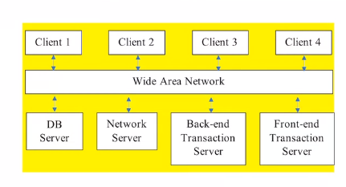

- Differentiate the following pairs of control model:

- Call-return model and manager model
Call-return model
  - A top-down sub-routine model
  - Applicable for sequential systems
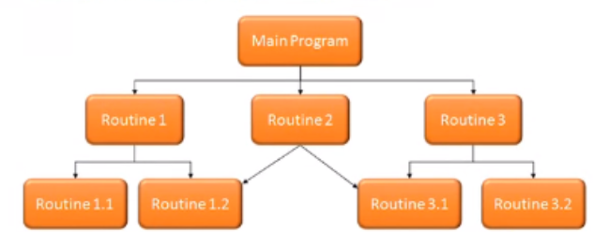

Manager model
  - A system component is designated as system manager
  - Processes (sub-systems) can execute concurrently
  - Applicable for concurrent system
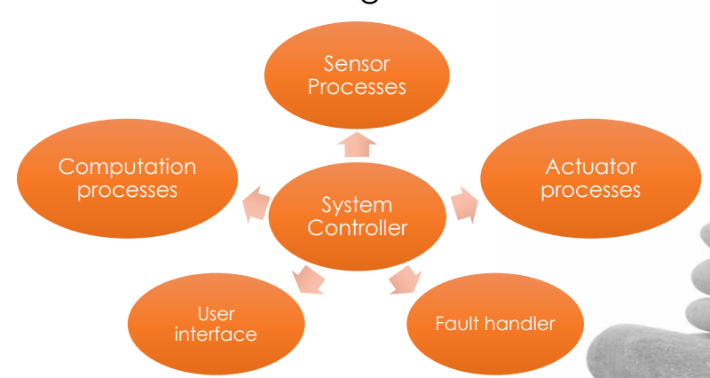

- Interrupt-driven model and broadcast model
Interrupt-driven model
  - Used in real-time systems where interrupts are detected by an interrupt handler and passed to some other component for processing
Broadcast model
  - An event is broadcast to all sub-systems. Any sub-systems which can handle the event may respond to it.
  - Effective in integrating sub-systems distributed across different computers on a network
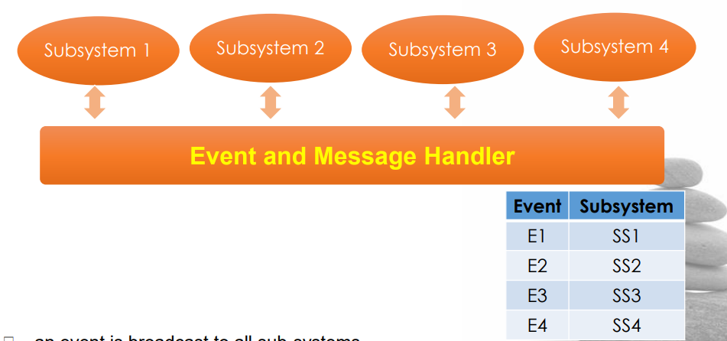

- Giving reasons for your answer, suggest an appropriate system organization model for the following systems:

- An automated ticket issuing system used by customers at a cinema.
Repository model

- A Sales and Inventory System used by Sales Staff and Inventory Staff in an organization
Repository model or Client-Server model

- A Sales Invoicing System will firstly take the customer order transactions and itemize unit price from database, follow by totaling up all the items ordered prices to calculate the invoice amount. The system will then deduct the invoice amount with a discounted rate (if any) and this will produce the final invoice amount. Then the system will update the customer account and finally print the invoice for each customer.

Giving reasons for your answer suggest a suitable control model for the above system. You may state any assumptions to support your answer.

Call return model of control. Each operation involves identifying particular options then calling subroutines to retrieve or computer the required information. There are no unexpected events to be processed. Furthermore, the operations will be performed one after another in sequential manner.

- XinJin Press is a newspaper company which started its first printed newspaper in 1960s. Recently, you are invited to attend a discussion meeting with XinJin Company’s IT department. The main agenda of the meeting is to decide on the maintenance of some of their legacy systems. One of their legacy systems is a text file storage server which stores large amount of the newspaper draft contents (original story from the interview, news draft, supporting images or news, and et cetera). The file storage system has no documentation and no proper module design. The draft contents might be useful in the future to trace the original story.

Assuming that XinJin IT department decided to re-engineer the legacy system. Propose 1 system organization/structuring design model. Explain and justify your answer.

Repository model: All shared data is held in a central database. This model is suitable if there is a large amount of data to be shared.
- The data is to be shared throughout the organization
- Since the file storage system was developed since their establishment in the year of 1960s, there should be large pool of data stored.

- Easy2Study.com is a global marketplace for teaching and learning online where students are mastering their skills. The system allows the students to search, view available courses, purchase, make payment, and join the courses. An access to start the course will be given once the payment is confirmed. Easy2Study.com is planning to extend their online system on mobile platforms to attract more customers as mobile users are increasing extremely.

Suggest and explain 1 suitable system organization model and 1 control modelling model for the Easy2Study.com mobile application. Discuss your answers.

System organization model – Client-server model
It’s a suitable model for Easy2Study.com mobile application which can provide specific services such as to search, to view available courses, to purchase, make payment, and join the courses and allows set of clients which call on these services to access servers.

Control modelling model – Centralized control
It’s a suitable model for Easy2Study.com mobile application where one sub-systems act as system manager has overall responsibility for control and starts and stops other sub-systems which handling to search, to view available courses, to purchase, make payment and join the courses.

